Outstanding Service to the Industry Award Nomination Form | 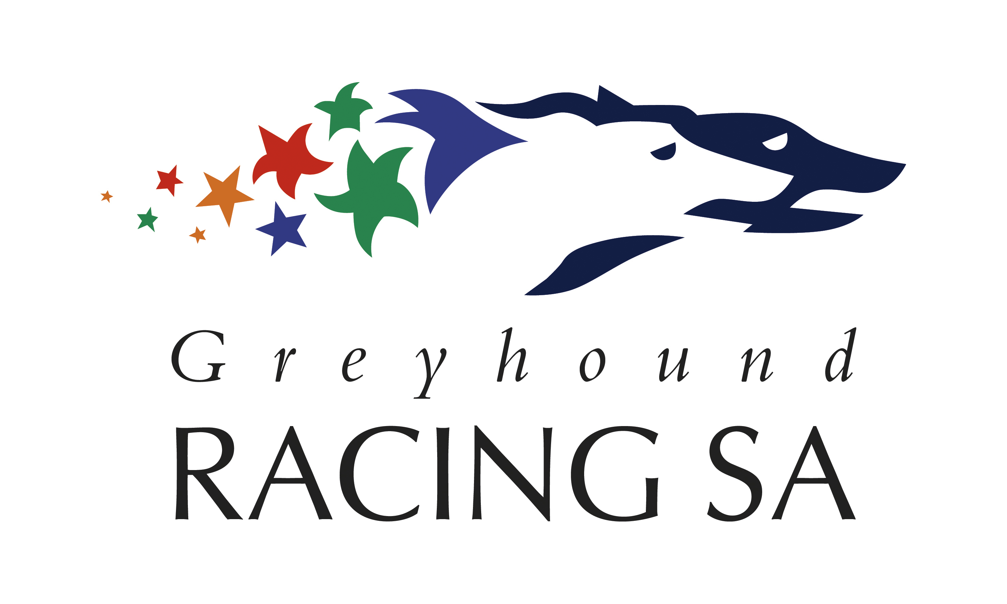

Nominee’s Details (Person that is nominated to receive the award)
Name
Street Address
Suburb, Post Code
Home Phone
Mobile Phone
E-Mail Address

Nominated by…
Name
Street Address
Suburb, Post Code
Home Phone
Mobile Phone
E-Mail Address

Please list the reason/s why your nominated person should be considered for the GRSA’s Outstanding Service to the Industry Award. Feel free to attach a separate page should the space below be insufficient.

Agreement and Signature

By submitting this application, I affirm that the facts set forth are true and complete.
Name (printed)
Signature
Date
Please forward your nomination to shaun.mathieson@grsa.com.au, fax (08) 8268 2870 or GRSA, PO Box 2352, Regency Park, 5942 by COB Friday January 20 2017. Winner to be announced at the 2016 Greyhound of the Year Awards Dinner held on Feb 10, 2017. Decision of the judging panel will be final.

