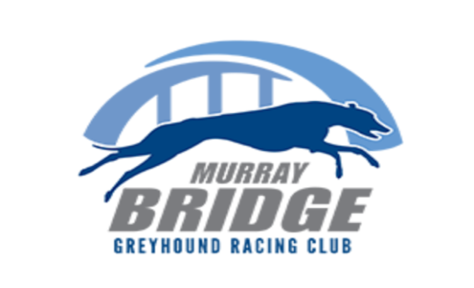

Murray Bridge Greyhound Racing Club

2 Kennett Road, Murray Bridge East SA 5253

www.murraybridgegreyhounds.com.au
robin.loechel@grsa.com.au

ABN 98 539 133 420

2021/2022 Membership Application & Tax Invoice

We are pleased to suggest a range of options for you and welcome you as a member

The options include:
- Club Membership & Voting Rights
- 10% discount on food and beverage, 1 free coffee
- Free Trials [Trainer Membership Only]
- Representation within the industry

I wish to renew/apply for Membership of the Murray Bridge Greyhound Racing Club for
2021/2022. Please tick / hi-light the membership that best suits you.

Registered Trainer Membership $100 Please make cheques payable to
Registered Trainer Joint Member plus $ 50 Murray Bridge Greyhound Racing Club

Club Member MBGRC $ 30 EFT: BSB 085762 ACC 313372104
Club Joint Member MBGRC plus $ 15 Reference your name and membership

TOTAL FEE PAYABLE $..........

PLEASE COMPLETE YOUR DETAILS (and return to Club Manager)

NAME…………………………………………………………………………………………………………...

NAME [Joint Member]…………………………………………………………………………………………

POSTAL ADDRESS………………………………………………………………………………………….

……………………………………………………………………………………………P/C…………………

EMAIL…………………………………………………………………………………………………………..

PHONE…………………………………………………………………………………………………………

Signed: ……………………………………………………………….Date: …..…………………………….

